**GitHub – getting started**

1. **GitHub ID:** Go to <https://github.com/> using Google Chrome (download if you don’t have it as this is the recommended browser for GitHub) and create an account for yourself. Once you have done this, send your GitHub username to [arunion@usf.edu](mailto:arunion@usf.edu) and I will add put you in the appropriate group/team.
2. **Download/install GIT** – see GIT install instructions document.
3. **ID/Folder setup:** Once you have downloaded/installed GIT, you can proceed with these steps:
4. open gitbash from the start menu and set your global values by executing the commands below. You must put your github.com username (i.e. “arunion”) and the email address you put in github.com (i.e. [arunion@usf.edu](mailto:arunion@usf.edu)):

                           $ git config --global user.name "arunion"

                           $ git config --global user.email [arunion@usf.edu](mailto:arunion@usf.edu)

1. in gitbash, run the following command and send your userid to [arunion@usf.edu](mailto:arunion@usf.edu):

           echo $(id –u –n)

1. Create a github folder on your C drive (developers).

(CM support only – create a cmgithub folder on your C drive)

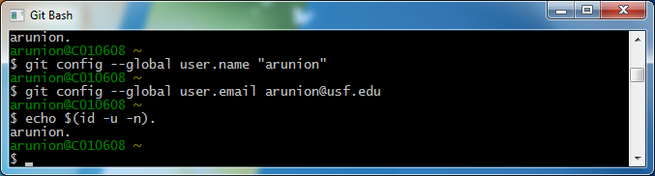

1. **Clone the repositories that you work on:**

This is a one-time step and will not need to be repeated unless a new repository is added:  
developers: go to the Z drive🡪github🡪developers and run clone.shl for each repository that you will be working on:

Group/Team Repositories needed

------------------ ---------------------------

ABS absfam, absfbog, absgam, absgbog

AIS aisdw

OASIS oashits, oasadms, oasam, oasban, oasbdmsam, oasbdms,

oasbog, oasdgwks, itam

SAAS (Jyothi) saas

UFA (Steve, Kristian, Doug) faam

**Note: Everyone should have these permissions at this point, but in case new developers/CM support personnel come:**

Developers need read/write access to\\nasstor.fastmail.usf.edu\Apps\gitreps and read access to \\nasstor.fastmail.usf.edu\Apps\github\developers.

CM support needs read/write access to \\nasstor.fastmail.usf.edu\Apps\github\cm and read access to \\nasstor.fastmail.usf.edu\Apps\github\developers.